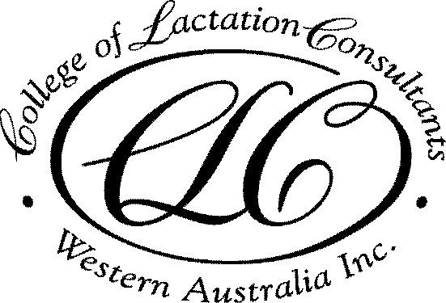

2018 Meeting Dates

Venue: Ngala, 8 George St, Kensington
Date/Time: 3rd Monday of the month, 7pm for a 7.30pm start
Cost: FREE for members, $15 for non-members

19 Feb | Case Report of a Breastfed Infant with Lactose Intolerance | Holly Tickner BSc
19 Mar | Tandem Feeding | Kelly Adams RN, ABA BC
16 Apr | Pesticides in breast milk: is it safe? | Dr Melvin Gaye  UWA
21 May | The role of laser in tongue tie division; a pilot study | Kaye Talijancich /  Dr Gera
18 June | Preliminary findings on mastitis study | Leanda McKenna  Curtin University
16 July | Ethics topic | ? Ben Hartmann
20 Aug | Case report | CLCWA member
17 Sept
15 Oct
19 Nov
Attendance certificates for CERPS will be issued at each meeting
In unforeseen circumstances the program may change without notice

For information about College Membership or other education programs
Visit our website www.lactationwest.org.au or email info@lactationwest.org.au

