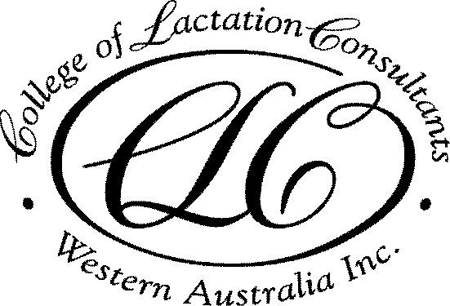

CLCWA 2018 Education Program

Venue: Ngala, 8 George St, Kensington
Date: 3rd Monday of the month
Time: 7pm start, education session 7.30pm – 8.30pm
Cost: FREE for members, $15 for non members

Date | Session Title | Speaker | CERPS
19 Feb | Case report of a breastfed infant with lactose intolerance | Holly Tickner BSc | 1L
19 Mar | Tandem feeding | Kelly Adams RN,  ABA BC | 1L
23 Apr | Pesticides in breast milk: is it safe? | Dr Melvin Gay | 1L
21 May | The role of laser in tongue tie division; a pilot study | Kaye Talijancich /  Dr Gera | 1L
18 June | Preliminary findings on mastitis study | Dr Leanda McKenna | 1L
16 July | Ethics of human milk banking | Dr Ben Hartmann TBC | 1E
20 Aug | Clinical case report | CLCWA member TBC | 1L
18 Sept | Assessing milk production | Dr Jackie Kent TBC | 1L
16 Oct | Ethics topic | TBA | 1E
19 Nov | What keeps mothers breastfeeding to 6 months | Prof Yvonne Hauck TBC | 1R

Attendance certificates for CERPS will be issued at each meeting
In unforeseen circumstances the program may change without notice

For information about College Membership or other education programs
Visit our website www.lactationwest.org.au or email info@lactationwest.org.au
Mobile 0419 939 553

CONTENT ABSTRACTS

19 Feb
Case report of a breastfed infant with lactose intolerance.
Holly Tickner BSc
Holly will report the presentation, investigations and management of an exclusively breastfed infant that was diagnosed with primary lactose intolerance.
Published evidence for the investigation and management of these infants will be reviewed.

19 March
Tandem feeding
Kelly Adams BSc RN, ABA Breastfeeding Counsellor
Kelly will explore the documented history and experiences of mothers that have tandem breastfed. Advantages and challenges, common concerns and societal responses will be explored. Kelly will provide strategies for supporting tandem feeding families in the community and in health care settings.

23 April
Pesticides in breastmilk: is it safe?
Dr Melvin Gay
While pesticides are commonly used, they are typically not visible after application and can be unknowingly absorbed by the human body. It is known that pesticide residue can be detected in human milk. While pesticide use has changed over time, it has been unclear whether this has reduced exposure for breastfed infnats. Dr Gay will present the results of his research in this area.

2 May
The role of laser in tongue tie division; a pilot study
Kaye Talijancich / Dr Gera
The results of a pilot study on breastfeeding outcomes in 49 mothers following their infant’s laser frenectomy will be presented.

18 June
Preliminary findings on mastitis study
Dr Leanda McKenna
Ultrasound theryapy is often recommended for management of blocked ducts and mastitis, despite no published evidence for its efficacy. Dr McKenna will present the results of her evaluation of ultrasound treatment on mastitis in breastfeeding mothers, and implications for clinical practice.

