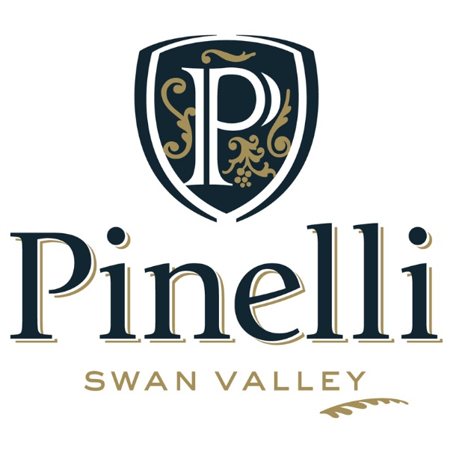

PREMIUM WINE LIST
James Halliday Wine Companion 2017, 4.5 star winery
DRY WHITES
Sparkling Juliet 2015 $26
Traditional method Sparkling wine with citrus notes on a creamy palate
Vermentino 2016 Reserve $18
Fresh lime and green apple characters with refreshing acidity
Verdelho 2016 Reserve $17
Delightful passionfruit and citrus characters with a soft rounded finish
Sauvignon Blanc 2016 Reserve $21
Loaded with tropical fruits on the nose and palate with a soft lingering finish
Chenin Blanc 2007 Family Reserve $35
(4 x Trophy and Gold medal winner Swan Valley Wine Show 2016, Huon Hooke 95/100, 5 star, Gold medal)
Concentrated palate of honey and toasted nuts and a soft finish
REDS
Breanna Rosé 2016 (Silver Medal Swan Valley Wine Show) $16
Delicious strawberry and raspberry characters abound with a crisp finish
River Block Red $12
Lighter bodied red with a soft and fruity palate. Made for easy drinking
Cabernet Merlot 2015 Reserve $21
Lingering notes of blackcherries and violets on the nose and palate
Shiraz 2015 La Tavola (Gold Medal Swan Valley Wine Show) $26
Soft palate with flavours of plum, blackberries and chocolate notes
Cabernet Sauvignon 2014 Reserve $24
Blackcurrant and red berry characters with ripe tannins
Durif 2015 Reserve $32
(Huon Hooke 95/100, 5 star, Gold medal)
Red wine of distinction with rich concentrated mulberry and plum characters
Durif 2014 Reserve $45
(Huon Hooke 95/100, 5 star, Gold medal, Trophy Winner Swan Valley Wine Show 2015, Silver Medal Perth Royal Show 2015, Silver Medal Swan Valley Wine Show 2016)
Red wine of distinction with rich concentrated mulberry and plum characters
FREE DELIVERY ANYWHERE IN AUSTRALIA
(12 x 750ml/500ml bottle purchases)

PREMIUM TASTING LIST
James Halliday Wine Companion 2017, 4.5 star winery

SWEET WINES
Chenin Blanc 2016 Reserve $16
Intense apple and floral characters with some balanced sweetness
White Moscato Frizzante 2016 (500ml) (Silver Medal Swan Valley Wine Show) $14
Flavoursome tropical fruit flavours with well-balanced sweetness and a spritz
Pink Moscato Frizzante 2016 (500ml) $14
Delicious pink fairy floss and rosewater characters with a spritz
Late Harvest 2016 (500ml) $16
Luscious sweet wine with floral and tropical notes

FORTIFIED (Limited Releases)
Aged Tawny $22
Rich and complex extended barrel aged characters with a long warming finish
Liqueur Verdelho (375ml) $32
Soft mouth feel with honeysuckle flavours and a lingering finish
Grand Tawny (375ml) $55
Luscious fortified with richness and flavour complexity of many years of aging

FREE DELIVERY ANYWHERE IN AUSTRALIA
(12 x 750ml/500ml bottle purchases)

Delivery for less than 12 bottles
WA DELIVERIES: $15 per carton
INTERSTATE DELIVERIES: $30 per carton

International shipping prices to be advised by emailing cellardoor@pinelliwines.com.au

