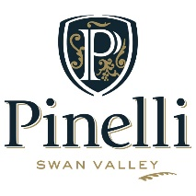
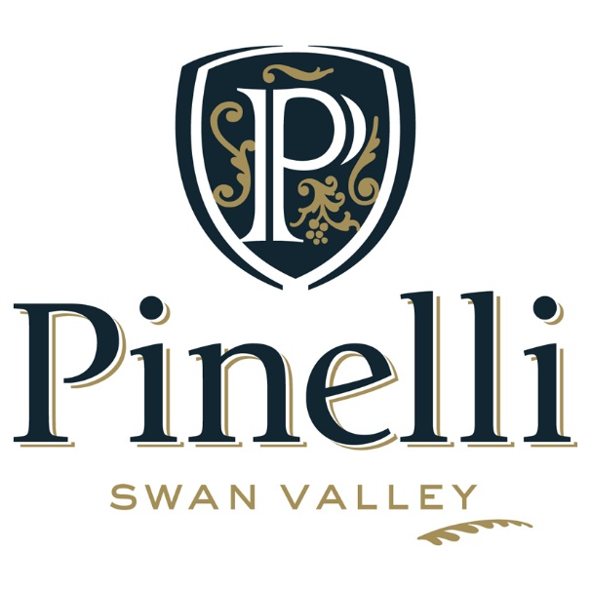

PREMIUM TASTING LIST

DRY WHITES
Sparkling Juliet 2015 $26
Traditional method Sparkling wine with citrus notes on a creamy palate
Verdelho 2016 Reserve $17
Delightful passionfruit and citrus characters with a soft rounded finish
Sauvignon Blanc 2016 Reserve $21
Loaded with tropical fruits on the nose and palate with a soft lingering finish
Chenin Blanc 2017 Reserve $16
Intense apple and floral characters with some balanced sweetness
REDS
Breanna Rosé 2017 (Silver medal, Swan Valley Wine Show) $16
Delicious strawberry and raspberry characters abound with a crisp finish
River Block Red $12
Lighter bodied red with a soft and fruity palate. Made for easy drinking
Merlot 2016 La Tavola ` $18
Flavoursome red berry characters on a soft palate with a rounded finish
Cabernet Merlot 2015 Reserve $21
Lingering notes of black cherries and violets on the nose and palate
Shiraz 2016 Reserve $26
Elegant wine with lingering blackcurrant and plum characters with a rich palate
Durif 2015 Reserve $28
(Huon Hooke 95/100, 5 star, Gold medal)
Red wine of distinction with rich concentrated mulberry and plum characters

FREE DELIVERY ANYWHERE IN AUSTRALIA
(12 x 750ml/500ml bottle purchases)

PREMIUM TASTING LIST

SWEET WINES
White Moscato Frizzante 2016 (500ml) (Silver Medal Swan Valley Wine Show) $14
Flavoursome tropical fruit flavours with well-balanced sweetness and a spritz
Pink Moscato Frizzante 2016 (500ml) $14
Delicious pink fairy floss and rosewater characters with a spritz
Late Harvest 2017 (500ml) $16
Luscious tropical fruits flavours with a clean sweet palate and balanced sweetness
FORTIFIED (Limited Releases)
Aged Tawny $22
Rich and complex extended barrel aged characters with a long warming finish
Liqueur Muscat (500ml) $35
Delicious raisins, caramel and orange peel characters with a warming finish
Liqueur Verdelho (375ml) $32
Soft mouth feel with honeysuckle flavours and a lingering finish
Grand Tawny (375ml)(Gold medal, Swan Valley Wine Show) $55
Luscious fortified with richness and flavour complexity of many years of aging

FREE DELIVERY ANYWHERE IN AUSTRALIA
(12 x 750ml/500ml bottle purchases)

Please ask our staff for more information on
International deliveries or travel allowances

