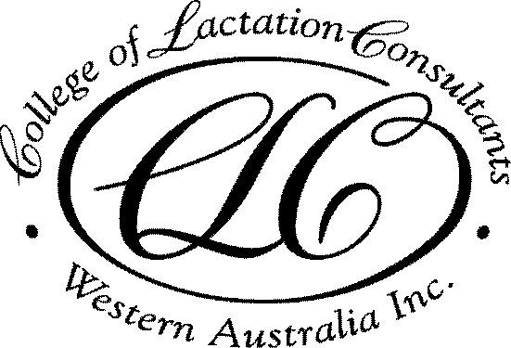

CLCWA 2018 Education Program

Venue: Ngala, 8 George St, Kensington
Date: 3rd Monday of the month
Time: 7pm start, education session 7.30pm – 8.30pm
Cost: FREE for members, $15 for non-members

Date | Session Title | Speaker | CERPS
19 Feb | Case report of a breastfed infant with lactose intolerance | Holly Tickner BSc | 1L
19 Mar | Tandem feeding | Kelly Adams RN,  ABA BC | 1L
23 Apr | Pesticides in breast milk: is it safe? | Dr Melvin Gay | 1L
21 May | The role of laser in tongue tie division; a pilot study | Kaye Talijancich RN | 1L
18 June | Preliminary findings on mastitis study | Dr Leanda McKenna | 1L
16 July | Ethics of human milk banking | Dr Ben Hartmann | 1E
20 Aug | Drugs and Breastfeeding | Steve Lewis BSc | 1L
17 Sept | Assessing milk production | Dr Jackie Kent | 1L
15 Oct | Do nipple shields affect milk transfer? | Viviane Coentro BSc | 1L
19 Nov | What keeps mothers breastfeeding to 6 months? | Prof Yvonne Hauck | 1L

Attendance certificates for CERPS will be issued at each meeting
In unforeseen circumstances the program may change without notice

For information about College Membership or other education programs
Visit our website www.lactationwest.org.au or email info@lactationwest.org.au
Mobile 0419 939 553

CONTENT ABSTRACTS

19 Feb
Case report of a breastfed infant with lactose intolerance.
Holly Tickner BSc
Holly will report the presentation, investigations and management of an exclusively breastfed infant that was diagnosed with primary lactose intolerance.
Published evidence for the investigation and management of these infants will be reviewed.

19 March
Tandem feeding
Kelly Adams BSc RN, ABA Breastfeeding Counsellor
Kelly will explore the documented history and experiences of mothers that have tandem breastfed. Advantages and challenges, common concerns and societal responses will be explored. Kelly will provide strategies for supporting tandem feeding families in the community and in health care settings.

23 April
Pesticides in breastmilk: is it safe?
Dr Melvin Gay
While pesticides are commonly used, they are typically not visible after application and can be unknowingly absorbed by the human body. It is known that pesticide residue can be detected in human milk. While pesticide use has changed over time, it has been unclear whether this has reduced exposure for breastfed infnats. Dr Gay will present the results of his research in this area.

2 May
The role of laser in tongue tie division; a pilot study
Kaye Talijancich
The results of a pilot study on breastfeeding outcomes in 49 mothers following their infant’s laser frenectomy will be presented.

18 June
Preliminary findings on mastitis study
Dr Leanda McKenna
Ultrasound therapy is often recommended for management of blocked ducts and mastitis, despite no published evidence for its efficacy. Dr McKenna will present the results of her evaluation of ultrasound treatment on mastitis in breastfeeding mothers, and implications for clinical practice.

16 July
Ethics of human milk banking
Dr Ben Hartmann
The number of human milk banks is rapidly increasing worldwide. While donor milk provides a valuable contribution for preterm infants when the mother is unable to produce enough milk, there are many ethical questions around milk banking. What is the impact of receiving donor milk on mothers’ longer term breastfeeding outcomes? Who should be eligible to donate, and who should be eligible to receive donor milk? Ben will discuss the many issues in this complex field.

20 August
Drugs and breastfeeding
Steve Lewis
Mothers may be unsure about the safety of prescribed and over-the-counter medicines, and the advice provided on product information inserts is not always correct with regard to breastfeeding. Steve, a registered pharmacist with a special interest in this area, will provide an overview of current guidelines for a variety of drugs in breastfeeding.

17 September
Assessing milk production
Dr Jackie Kent
A variety of methods have been used to assess maternal milk production over the years, with the 24hr milk profile shown to be most accurate. Maternal perceptions of milk supply don’t always match actual supply. Jackie will give an overview of reference ranges for 24hr milk production in the weeks following birth, from 1 – 6 months, and observed productions at 6 – 12 months.

15 October
Do nipple shields affect milk transfer?
Viviane Coentro BSc, PhD candidate
Nipple shields have been used in various forms for hundreds of years, although the design and materials have changed over time. Findings from two studies using thick rubber and thin latex nipple shields suggest that nipple shields may reduce milk transfer. Viviane will present the findings of her study of ultra thin silicone nipple shied use in breastfeeding mothers with unexplained nipple pain, and mothers with no breastfeeding difficulties, and the effects on milk transfer.

19 November
What keeps mothers breastfeeding to 6 months?
Prof Yvonne Hauck
While most Australian mothers initiate breastfeeding, there is a rapid rate of weaning in the months after birth. Prof Hauck will present the results of a multi-national study that investigated factors that mother reported as important to their continued breastfeeding to 6 months.

